**Assignment No.02   
SSD Diagram + Collaboration Diagram + Operational Contract**

|  |
| --- |
| **Project Title:** **Cryptocurrency Exchange** |
| **Project Members:** 04   |  |  |  |  | | --- | --- | --- | --- | | Name | Registration # | Email Address | Signature | | Muhammad Ali Tipu | BSEF18A035 | [Bsef18a035@pucit.edu.pk](mailto:Bsef18a035@pucit.edu.pk) |  | | Sheraz Ahmad | BSEF18A036 | [Bsef18a036@pucit.edu.pk](mailto:Bsef18a036@pucit.edu.pk) |  | | Muhammad Umair Mubasher | BSEF18A038 | [Bsef18a038@pucit.edu.pk](mailto:Bsef18a038@pucit.edu.pk) |  | | Usama Imtiaz | BSEF18A043 | [Bsef18a043@pucit.edu.pk](mailto:Bsef18a043@pucit.edu.pk) |  | |

**Collaboration Diagram**

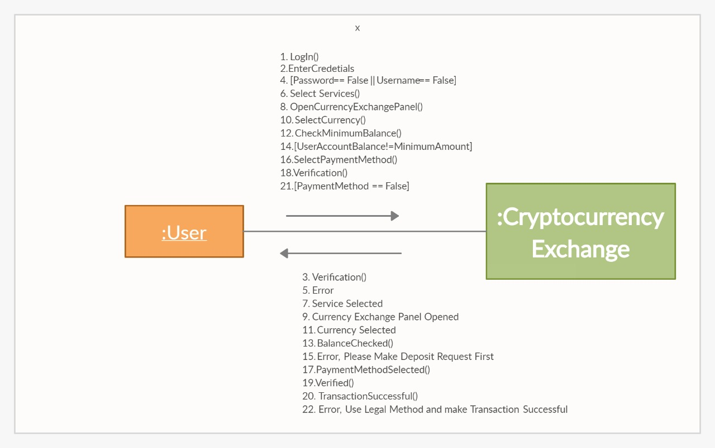

**SSD Diagram**

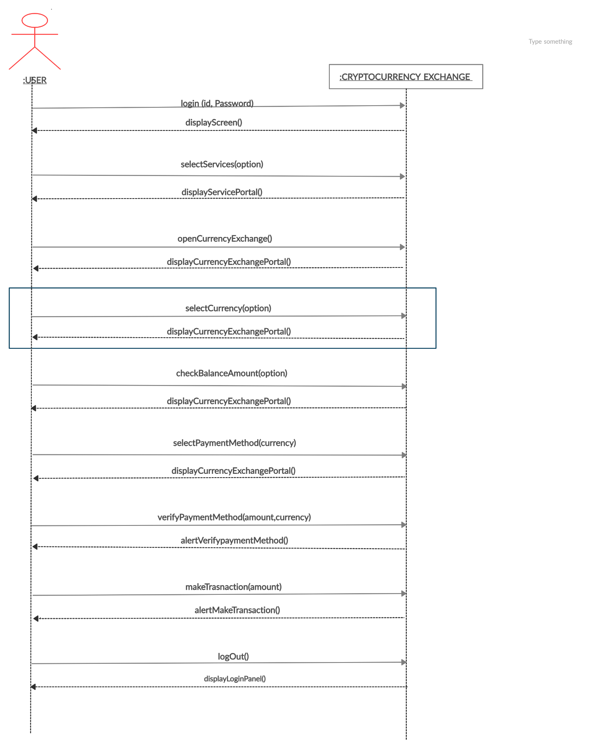

**Operations Contract:**

|  |  |
| --- | --- |
| **Name** | UC_User_Make_Currency_Exchange_Request |
| **Responsibilities** | Select currency exchange service and sent request to exchange handler, perform event and make transaction successful and report to admin |
| **Cross Reference** | Use case: select currencyExchangeService() |
| **Exceptions** | None |
| **Pre-condition** | User must be authenticated. |
| **Post condition** | User found service of his choice |